**ORDER MANAGEMENT SYSTEM**

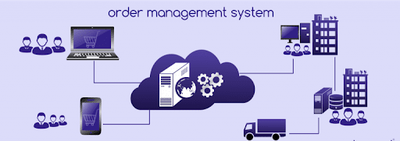

**PREPARED FOR**

SFDC Training Program

Capgemini Technology Services

**PREPARED BY**

Aditya Vikram Sarkar

**Abstract:**

The Order Management System is a Salesforce based solution for Orders.It consolidates data provided by different product brands and provide the user details like price,quantity,discounts,etc in real-time.The user may want to choose different products based on different aspects,our system allows them to make a search based upon Product Name,Brand and MRP and can select products based upon the shown product list.The Lightning App allows them to confirm order and cancel order and a invoice will be shown at the end.All the users,roles,reports are managed my the Support Team,no other users are allowed to delete any records apart from Support Team.Email notifications are sent to respective user and it’s contacts when stage of order is changed.

**Scope :**

Inscope:

Following is the functionality provided by the system:

There are three categories of people who access the system: Sales User,Business User and the Support Team.Each of them has different privileges.

1. The Sales User can:

* Login
* Create Order
* Cancel Order
* View Order Details
* Generate Approvals(Order amount above 100000)
* View Reports

1. Business Users can:

* Login
* View Orders and Invoices
* View Reports
* Accept/Reject Approvals

1. Support Team can:

* Login
* Create Users
* Assign Roles
* Create/View/Edit Orders
* CRUD Operations on Records

Outscope :

The following constrains in the project:-

1. Only deletion of records are available to support teams.
2. Sales user can at max handle 5 accounts.
3. Business Users at max can handle 10 accounts.
4. No user can view other users data,exception support team.

**Class Diagram:**

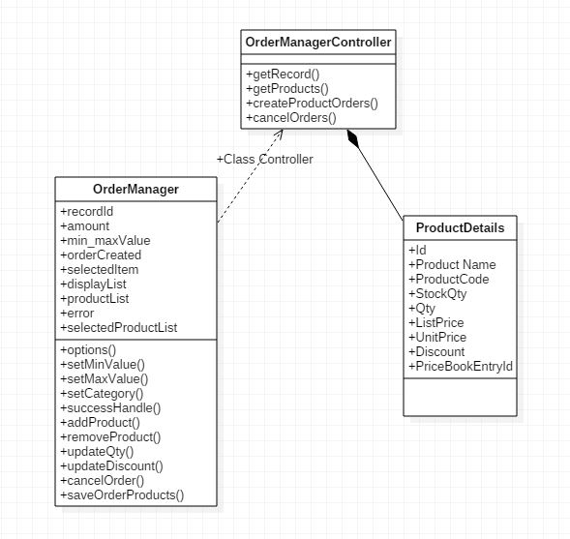

**Sequence Diagram for Sales User:**

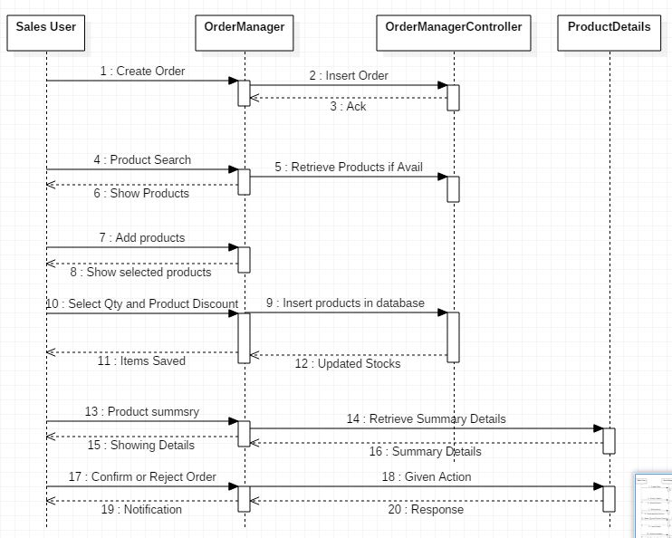

**UseCase Diagram:**

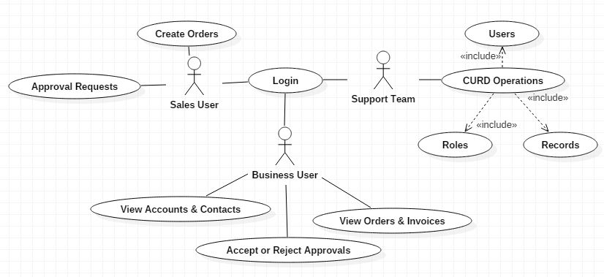

**Activity Diagram for User:**

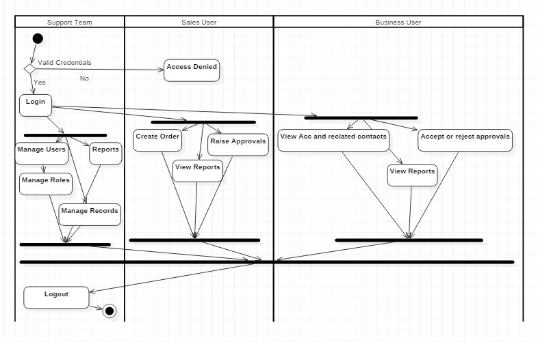

**Flowchart Diagram :**

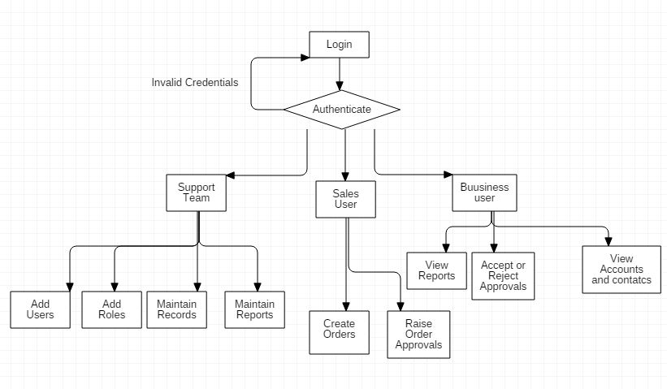

**Creating Order**

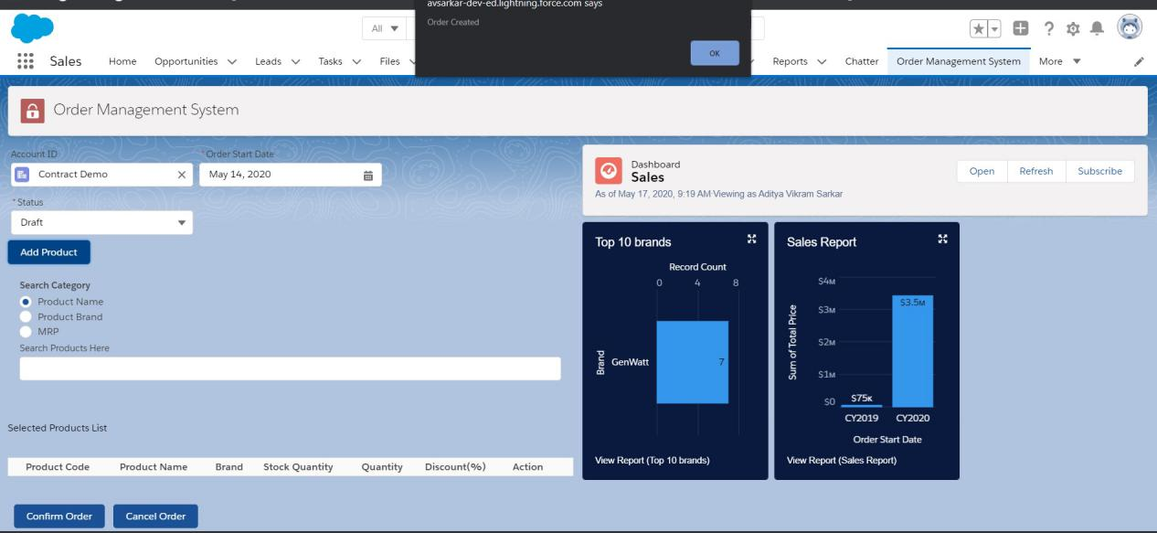

**Adding products to the order:-**

**Searching Products:-**

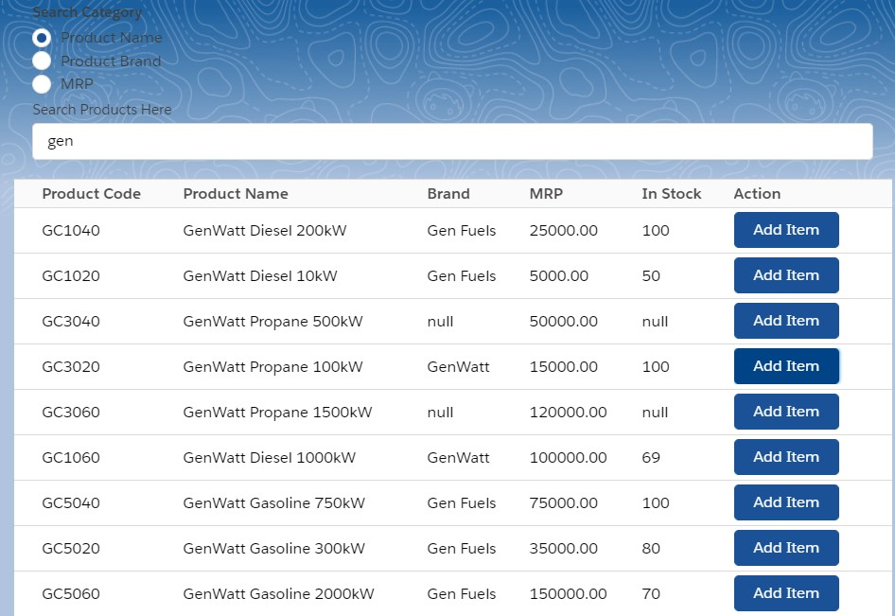

**Selecting products from searched Products assiging quantity and discount%.**

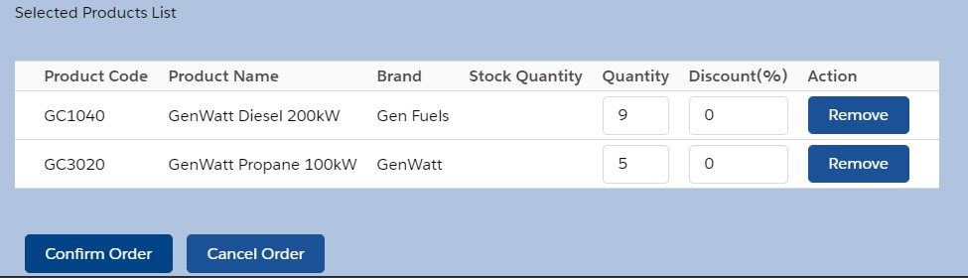

**Confirming Order**

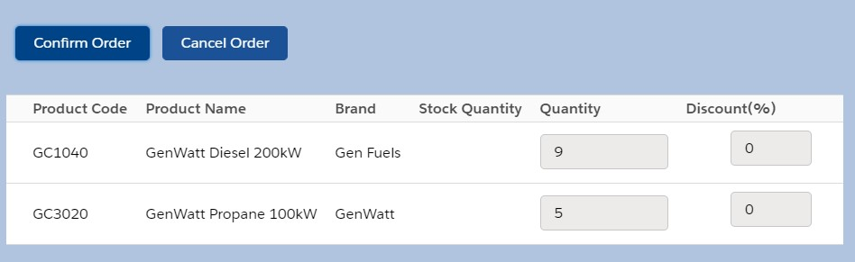

**Email Notification**

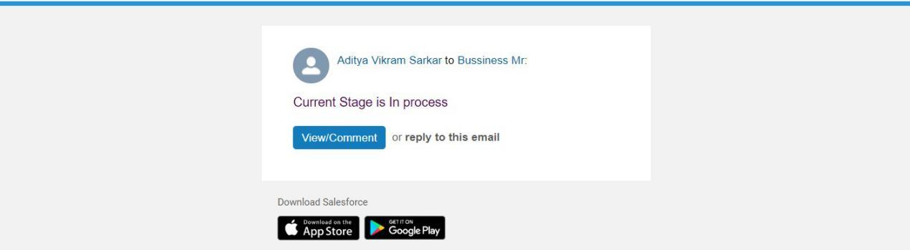

**Validation & Assumptions:-**

* Desired Quantity cannot be negative.
* Discount cannot be negative or more than 100%.
* Order after creation by sales user cannot be deleted,it can only be done by the Support Team/Admin.
* Stages cannot be changed to prior stages.
* Sales User can handle only 5 accounts.